**JENKINS-CI/CD Pipeline**

Tools:

* Git/Bitbucket
* Maven
* Docker
* Jdk11
* Integration – Jfrog

SonarQube

Grafana

Flow and tools- Roles:

**Git:**

* The code is changed and committed in the GitHub/bitbucket repository.
* GitHub plays the role of Server for our software code which maintains the logs and changes in our code.

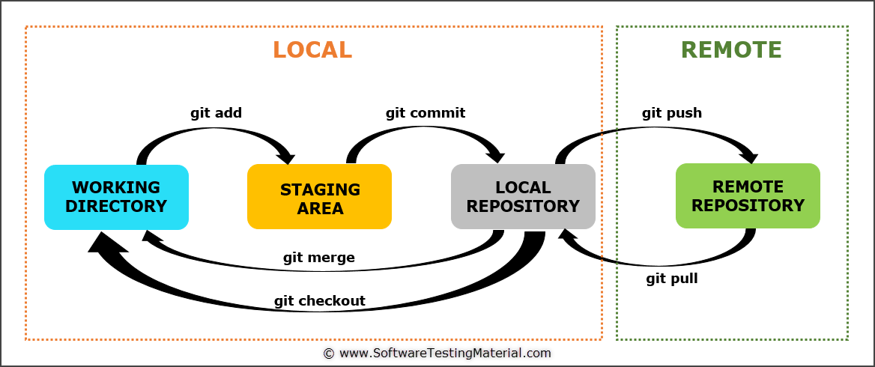

**Maven tool:**

* Maven Tool is used for building codes in our environment
* Clone the GitHub repo in our server
* Install maven tool and build the code in .war/.jar format

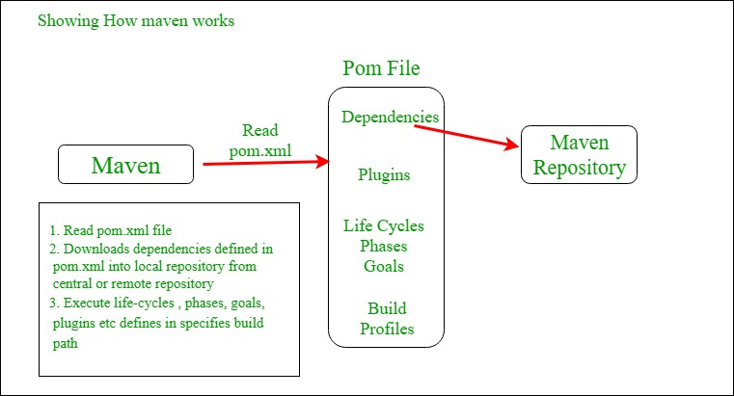

**Artifactory:**

* Create a repository in jfrog artifactory and push the build as an artifact to the repository.
* Get the entire software as a war file link which we can use for deployment
* Artifacts are the repo’s that are used for version controlling and maintaining the logs and update features in the code.

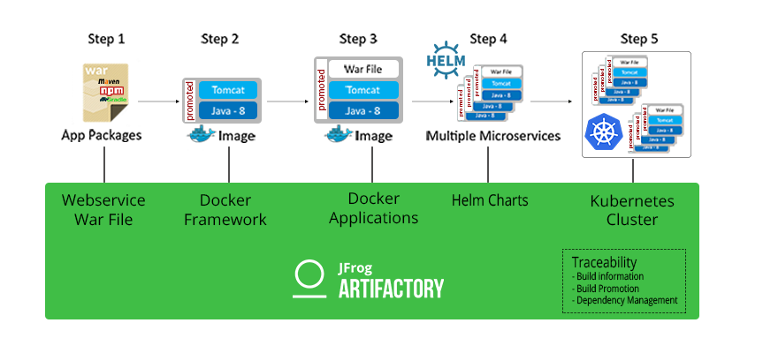

**SonarQube:**

* After the artifactory creation, the code is made mobile
* Check out its performance and bug status for editing or making new versioning.
* SonarQube is an analysis tool which is having dashboard and graphical representation of the code’s health and performance status.

Quality report

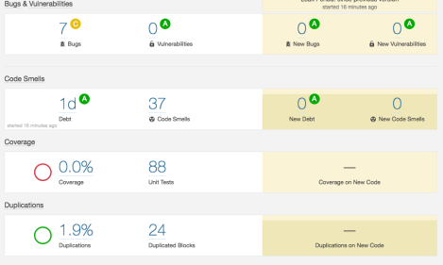

**Docker:**

* The code is available as a war file in artifactory
* Install docker and use the artifact to pull the code
* Run that code in docker as a container
* Then create a repository in Docker hub and push the container as a docker image to the hub.

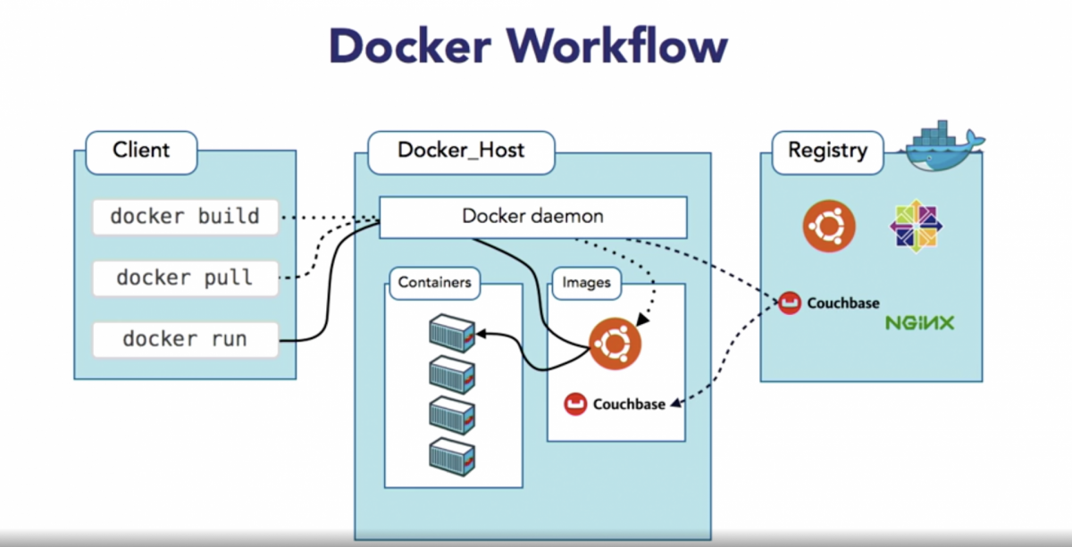

**Kubernetes:**

* Install kubernetes and deploy a cluster in a specific environment as needed.
* Pull the image from the docker hub.io and deploy it to the clusters
* Verify the running Pods in the cluster.

Installation:

curl -LO "https://dl.k8s.io/release/$(curl -L -s <https://dl.k8s.io/release/stable.txt)/bin/linux/amd64/kubectl>"

chmod +x kubectl  
mkdir -p ~/.local/bin  
mv ./kubectl ~/.local/bin/kubectl

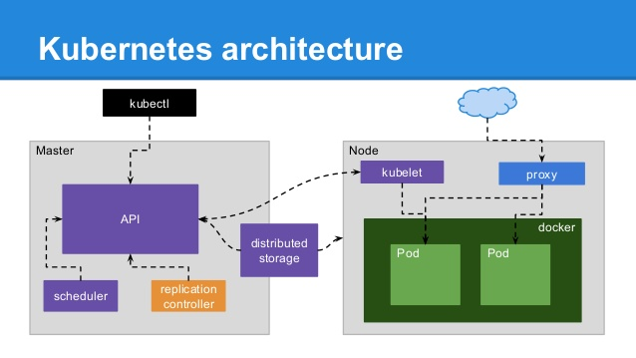

**Grafana:**

* Monitor the health check, Usage and DataSource utilization using Grafana tool.
* Install the Grafana tool in the cluster and monitor the Pods health and Performance.
* Install that by using wget

Wget <https://dl.grafana.com/enterprise/release/grafana-enterprise-7.3.6.linux-amd64.tar.gz>

tar -zxvf grafana-enterprise-7.3.6.linux-amd64.tar.gz

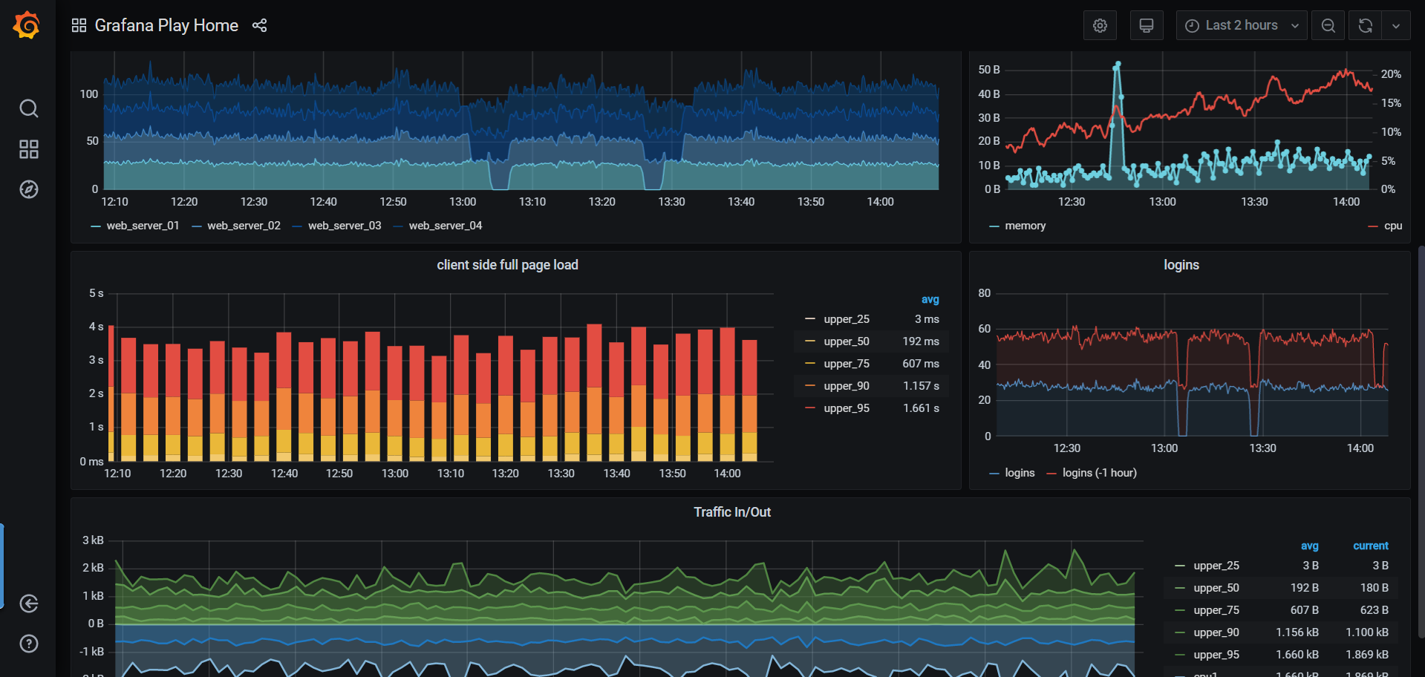

In Jenkins:

Write a script for

* GitHub authentication
* Jfrog artifactory authentication
* Docker authentication

Packages to be installed in Jenkins:

* Docker
* Maven
* Kubernetes
* GitHub

Jenkins makes all the integration and needed deployment by using agents and stages by scripts.

